MMF2 / TGF2 Active Object Tutorial

In order to use this tutorial you should already be familiar with the how event editor works. If you don’t know how to make events, conditions or actions, please read a tutorial that covers that topic first. Go to www.clickteam.com and look for the resources section.
The Active Object is the prime object in Multimedia Fusion. Probably all applications made in MMF2 have at least one active object. In the earlier klik products the Active Object was the only object that you could draw graphics for, assign movements to, give alterable values to and in general do fun stuff with at runtime. Today MMF2 offer quite a few objects that have the basics of the Active Object, but it’s only the Active Object that has the great and powerful Animation Editor.
Here is an overview of what you’ll learn in this tutorial:
- How to assign a movement to an object
- The basics of the animation editor
- How to import images
- How to import a series of animationframes
- The basics of alterable values
After reading this tutorial you will have a general knowledge of what you can do with the active object and how to do the most important things. You don’t need to read it from top to bottom. Each topic can be done separately.

How to assign a movement to an object
Let’s start by creating an Active Object. Right click in the Frame Editor and select Insert Object and then choose Active. Place it somewhere in the frame editor. For now it’s just an ugly green square.
Press F8 to run your application. What you see is not very amusing, is it?

Assign a movement to the object so we can move it around. Exit the application window if you haven’t already and you should be back in the frame editor. Left click on the Active Object. In the properties window, select the Movements tab. Now change the movement type from Static to Eight Directions.
Press F8 again. This time you can use the arrow keys to move the object!
Still, it looks rather dull. Let’s pimp the object!

The basics of the animation editor
Go to the frame editor and Double-click on the Active Object to enter the Animation Editor. You have now entered a very powerful tool which allows you to create and control all the animations that your object will use. You can either make you own graphics directly in the picture editor or import existing images or animations.
The picture editor is pretty basic. You can draw pixelart, make squares, circles, lines etc. It’s a basic drawing tool that lets you create graphics for your games and application really fast.
This is not a tutorial on how to use the different tools in the picture editor. Take some minutes to get used to it, draw some shapes and have fun.
Okey. I want to transform our Active Object into a car. First, click on the top left button labeled Clear to clear the frame. Then draw a nice looking car. The car will be seen from the air, in a top down perspective. You probably want to make the drawing area bigger. Click on the Size button or simply press W to open the Size properties and type in a proper size, for instance 64 * 32. Use the zoom slider or the mousewheel to zoom in and out.
On the bottom of the screen you see four direction arrows, and the right one is activated. That means that you currently are drawing the animation for moving right, so the car should be faced to the right also.

Here is my car:
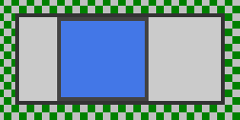
A true beauty!
When you are done drawing the car, click on the Crop button (ctrl+k) to crop the image. We want to create images for all the directions, but first we have to set the hotspot. The hotspot marks the actual position of the object. Click on the View Hotspot button or press H. Since the hotspot by default is at the top left corner, the car will rotate around that position. That will look pretty odd when you’re driving around. We want the car to act normal and rotate around the center. Simply move the hotspot where you want it or click on the middle Quick Move button.
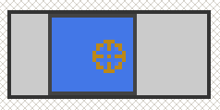
You see the slider below the direction arrows. Move it to the far right so that you’ll have 32 directions. Now right-click on the direction that contains an animation (the right one) and select Create Rotated Directions.
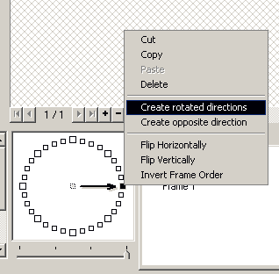
Take a look at the other directions. They now contain rotated versions of the car you just drew.
We are done in the animation editor for now. Click OK and go back to the frame editor.
Left-click the car and find the movement properties again. This time give it a racing car movement. Now press F8 to test your car!

How to import images
For big projects you often want to create your graphics in another software that is designed for creating images and animations, such as Gimp, Paintshop Pro, Photoshop or Flash. Multimedia Fusion 2 lets you easily import images in the most common formats.
First create an Active Object.
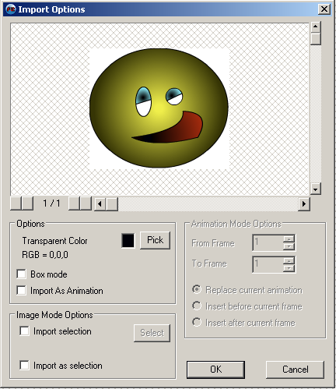
The first thing you want to do in the editor is to check take a look on the icons at the left. The ones important for us now are the 3 in the upper left corner; Clear, Import and Export. First clear the graphics that is already there by clicking the Clear button. You’ll see that the green square in the middle of the picture editor disappears.
Click on the Import button. We want to import the image called Smiley.png. In the same folder where you found this document you should see a folder named Graphics. You can find Smiley.png inside it.
You’ll see the Import Options window. The only thing you need to do here is to pick the gradient color. Click on the Pick button and then on the white background on the image. When that is done, click the OK button, and then OK again to leave the Animation Editor.
That’s how simple it is!

How to import a series of animationframes
Some graphics software lets you export an animation as a series of images. Multimedia Fusion 2 can load these images and create an animation of them in one go. Do the exact same thing as when we imported one image, but make sure the filename of the images has a number in the end.
Along with this tutorial you’ll find 50 images named Daynight0001.png, Daynight0002.png etc..
Open Daynight0001.jpg. Now MMF2 will open all the images from Daynight0001.jpg to Daynight0040.jpg. In the Import Options you have to select Import As Animation and choose White as the Transparent Color. Change the color by double-clicking it. Click OK and run the application!
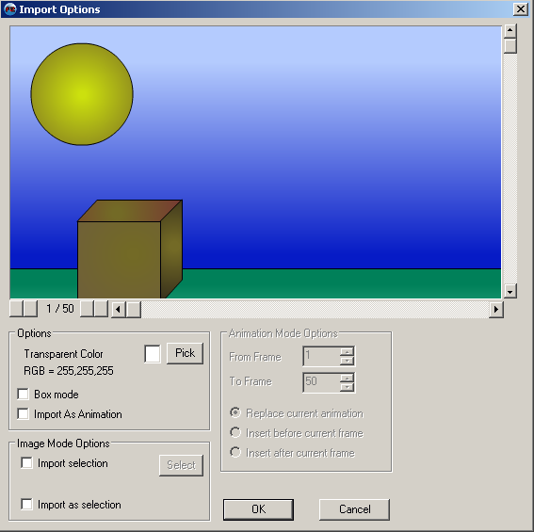

The basics of alterable values
Alterable values are values that are individual for each Active Object of the same type. Let’s say you have an Active object named Enemy. In your level you place lots of these enemies. The player control a spacecraft. When you shoot the enemy ships they shall not be destroyed until all their health runs out.
We can accomplish this by using alterable values.
Go to the Frame Editor. From the object libraries add one spacecraft and give it a human controlled movement. Also add another spacecraft or similar object which will be the enemy. Duplicate this enemy object by dragging it while holding CTRL and place several of it around the level.
Finally add a bullet. You can draw the bullet yourself if you want to. It doesn’t need to be fancy looking ;)
So now we have these 3 objects: Player, Enemy and Bullet. Name them whatever you want, but those are the names I will be referring to.
Click on one of the Enemy objects and go to the Values tab in the properties window.
Add a new alterable value and double click it to change its name from “Alterable value A” to “Health”. Finally change its value from 0 to 3. Notice how this affects ALL the duplicates of Enemy. This means that all the enemy spacecrafts will start with a health of 3.
Now let’s enter the event editor. Make the following event:
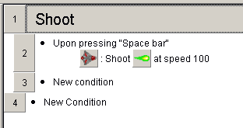
Since there are no names in the picture, here is the text based version:
- Upon pressing “Space bar”
- PLAYER: Shoot BULLET at speed 100

And now let’s do the fun part.
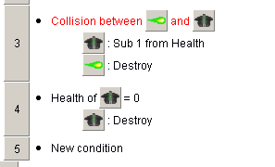
- Collision between BULLET and ENEMY
- ENEMY: Sub 1 from Health

Here’s the events in pseudo code:
#1: We shoot a bullet
#2: The bullet collides with an enemy and gets destroyed. The enemy lose 1 health.
#3: When the enemy is out of health, it gets destroyed.
NB! Because of the group the events in the picture are labeled 2, 3 and 4, instead of 1, 2 and 3.

Now try the game by pressing F8. Move around with the arrow keys and shoot with space bar. You’ll see how it takes 3 bullets to destroy an enemy? And also notice that each enemy has its own health. If you destroy one, the other ones are still around. This is a great way to separate one active object from another.

Spread values
Finally I want to explain how the spread values action works. Spreading values are very usefull, especially while working with fastloops. When you choose to spread a value into an object, MMF2 asks you which value to spread. If you choose 0, the spreading will start on 0. MMF2 scans through all the objects of that type and gives them a value starting on 0 and counting. The order of which the objects gets a value is decided by the view-order. So if you haven’t altered the view order, the first object created will get the value 0, the next one will get value 1, the next one 2, etc..

Credits
This tutorial was made by Kjetil Nossum alias Popcorn. I hope it gave you a little insight of how to use the active object in Multimedia Fusion 2 / The Games Factory 2.
If you have any questions or comments related to this tutorial, don’t hesitate to give me a message. I am always interested in learning how I can improve my tutorials.
My e-mail adress is ilikepopcorn@hotmail.com

